INTENDED USE

The ArmorZone™ TL-2 barrier (SWM17) is a high performing plastic water filled barrier designed to provide work zone barrier protection to temporary construction sites and other miscellaneous roadside activities. The water-filled nature of the barrier simplifies its deployment and transportation while increasing safety during the installation process as the empty barriers only weighs 58 kg and can be easily handled by two operators.

ArmorZone™ deployment involves interlocking the 2m long units with a unique ‘twin pin’ connecting rod and filling each barrier with 440L of water. ArmorZone™ can be deployed straight or with low curvature, on either roadside or median applications.

SWM17 is a MASH Test Level 2 accepted barrier

FEATURES AND SPECIFICATIONS

- Exceptionally good vehicle control and low deflection
- Available NCHRP 350 TL-2 End treatment (SCI29)
- Easy install and transportation
- No external steel structure
- UV Stabilised HDPE modules strong enough to absorb nuisance impact without repair
- Environmentally friendly – 100% recyclable
- 120 m/h deployment rate
- Overall Length: 2160mm (effective 2000mm)
- Height: 870mm; Width: 450mm
- Connector: Galvanised Steel
- Weight: 58kg (508kg when full); Water Required: 440L (per unit)
- Deflection TL-2 (MASH): 4.1m (2270kg, 70kph @ 25°)
- Length of Need: 26.0m
- Optional End Treatment: NCHRP 350 TL-2

APPROVALS

FHWA Acceptance Letter: B-223.

CONTACT INFORMATION

Armorflex International LTD
www.armorflex.co.nz
Telephone: +64 9 4269174
156 Foundry Rd
Silverdale, Auckland 0932
New Zealand

ARMORZONE™ PLASTIC BARRIER TL-2
SWM17 |  | 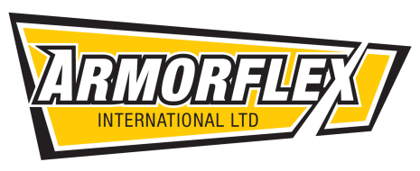
SHEET NO. | DATE
2 of 2 | 07/10/2013

